This article was published in The Chevron, Friday, March 5, 1976, pp. 14-15. At the time, The Chevron was the student newspaper of the University of Waterloo (UW), Ontario, Canada. Three weeks later the entire article was republished in The Sheaf, the student newspaper of the University of Saskatchewan, March 26, 1976, pp. 4-5.

Student as Worker:
Wages for Homework
by
Tim Grant

This feature was written for the chevron by Tim Grant, a fourth year Arts student at UW. It suggests that schoolwork must be viewed from the perspective that it is work, and therefore worthy of a wage, and that students should be seen as workers and not as "parasites". We hope by printing this article to open up discussion in this area, and would welcome response to it.

Most of us are at university because we see it as the route to better jobs and higher wages.

With higher wages, we hope to have more power to get what we want out of life — time to develop our interests, to enjoy family and friends — in a word, to do whatever we decide we want to do.

But in recent years, the chances of getting a well-paying job at the end of our 20-odd years of schooling have shrunk. There are fewer jobs available, and many of those available, such as teaching, have become much harder work.
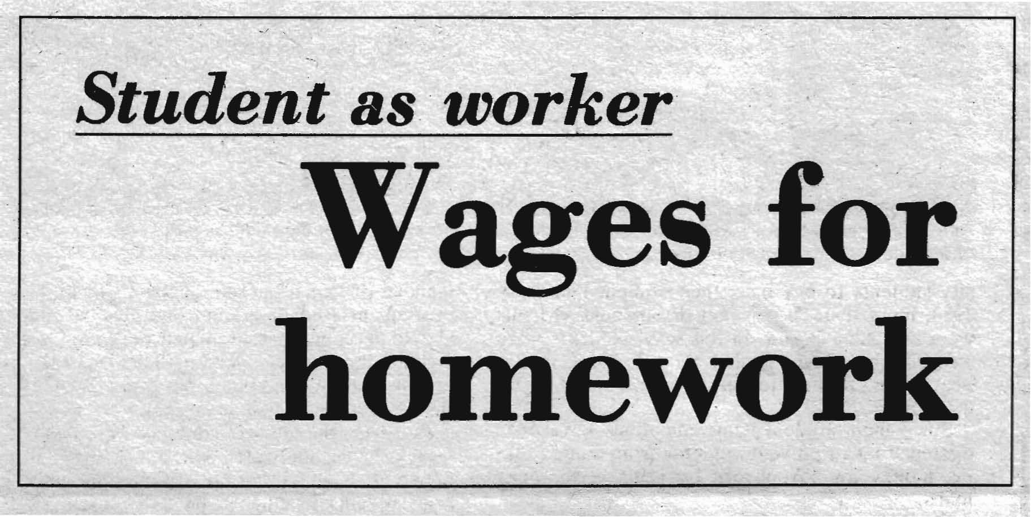
We also find that the pay levels for these jobs are not as high as we expect. With wage controls and staff reductions by both business and government, the picture is becoming grimmer. Statistics Canada estimates that between 1973 and 1980, more than 2.5 million students will receive post-secondary degrees, while only 600,000 jobs requiring these qualifications will become available.

With these things in mind, it has become very difficult for us to stomach three or four years of hard work and thousands of dollars of debts.
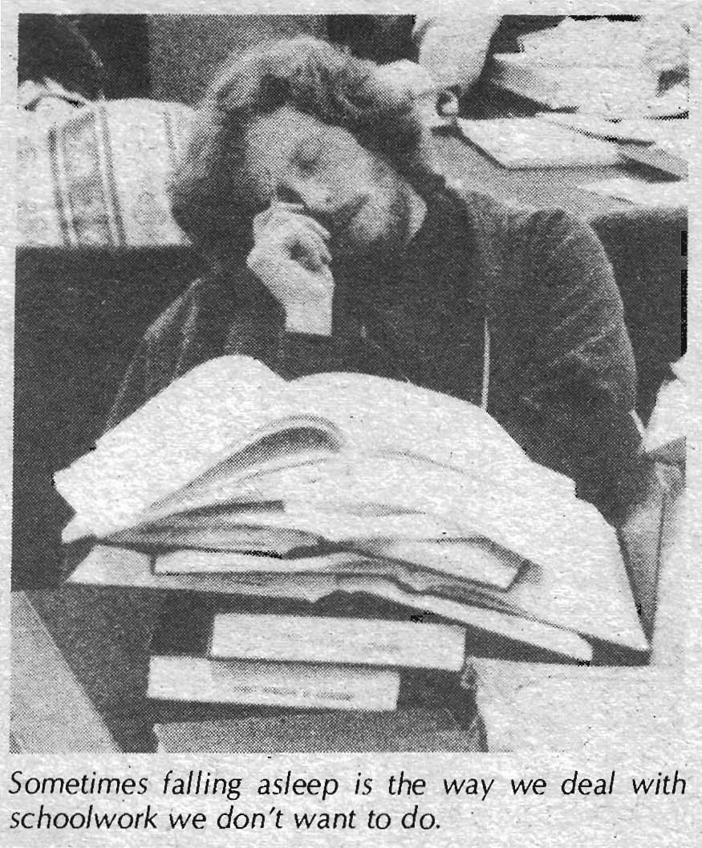
While it is clear our lives as students and our future prospects are increasingly uncertain, it is not as clear what we can do about it. Teachers, postal workers and all workers who receive a wage have an employer whom they confront over how much money they get and how much work they have to do. The outcome of that struggle determines how much time and money they have to do whatever they choose to do.

But for students, housewives and other workers who receive no wage, the absence of a wage has made it appear that we work only "for ourselves", or for husbands and children in the case of housewives. The Wages for Housework Movement, by clearly identifying that the maintaining and raising of the present and future labour force is essential work for the functioning of society, from which all employers benefit, has opened the way for students to see schooling as work.

As in the case of housewives, our lack of a wage has hidden the work we do in school, and has often defined us as parasites on the backs of our parents and the taxpayers.

But schoolwork is work, not only because it involves a lot of hassles, effort and long hours. More fundamentally, it is work because as students, we are actively engaged in producing a very important product — ourselves — as a specifically trained segment of the future labour force.

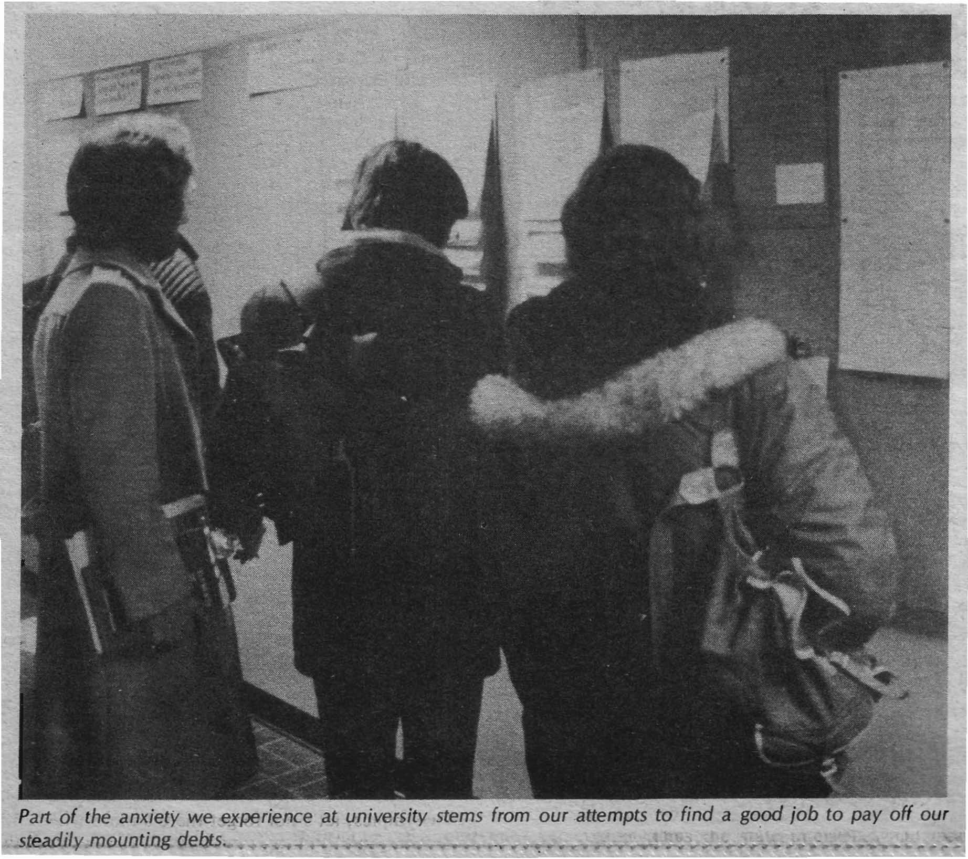
The work we do in school involves both acquiring knowledge and technical competence to perform certain jobs, as well as developing the self-discipline which will enable us to handle the daily routine of our future jobs.

While the work we do in schools appears to be for our own benefit, it is our future employers, who need our skills and self-discipline, who are the real beneficiaries of our work.

Schoolwork certainly feels like work. Even in the best courses, involving the most interesting books, being forced to read those books in a certain time limit, or write book reports, or study them for an exam, becomes an imposition on our time.

For men students, university was always seen as an investment towards a higher future income. The "investment" aspect of our schooling served to hide the work we were doing already.

For women students, university offered the hope of being able to avoid the fate of the full-time, wageless housewife. But as women have discovered, most university-trained women end up either as full-time housewives or in low-paid social service jobs which are extensions of housework.

When a university degree fails to deliver the wages which can satisfy neither men's 'investment' nor women's 'hope', we both confront the reality of schoolwork as unpaid work.

Wagelessness as a discipline

The lack of a wage for our schoolwork keeps us financially dependent on our parents and the state. Our wagelessness forces many of us to take part-time jobs in addition to full-times jobs as students. We also have to work full-time during what is supposed to be our summer 'vacation'.

We university students are not alone in being forced to take second jobs over and above our schoolwork. In Kitchener's largest downtown high school, three-quarters of the students had part-time jobs in 1974-75.

With so many wageless students competing with each other and with other workers for jobs, wages are kept down and those who get jobs are forced to work harder to keep them.

In the same way, our financial dependence on our parents becomes a discipline on them to work longer and harder, and is often the main factor forcing our mothers to take a second job outside the home, over and above her housework.

Finally, the fact that we don't get paid for our schoolwork, saddling us with large debts when we leave university, forces us to get a job immediately rather than travel, relax or do something we want to do.

When I left university a few years ago with a B.A., I was saddled with a $2,500 debt. I decided to stay in Kitchener because most of my friends were here. The only job I could find with a high enough wage to enable me to pay off my debt quickly was at the Uniroyal tire plant, working on rotating shifts. The consequences of my wagelessness as a student was driven home to me when I couldn't afford to refuse the job or all the overtime work on weekends.

My sister went to university at the same time I did, and ended up with a $4,000 debt. Two years later, she is still working to pay it off—I paid mine off within a year. The difference reflects the difference of power between men and women to command higher wages both during summer jobs and later after graduation.

Schoolwork and the state

The state has always understood the crucial economic function of schoolwork. One of the clearest statements of this recognition is the U.S. government study entitled Work in America, published two years ago.

The study reflects a clear perception of society as a huge "social factory", with each institution playing an important role in contributing to the overall profits of the economy. The study argues that schools should be restructured in various ways to reflect even more closely the needs of the labour market.

A recent article in Psychology Today, titled significantly "Civil War in the High Schools", reflects a growing awareness that conflicts within schools are inherent to their structure. The authors argue the need to introduce some form of collective bargaining between students and school officials, similar to the forms we know of in other workplaces.

Newspaper articles abound these days with titles such as, "Schooling blamed for unprepared labour", where government and employers complain that the educational system is not providing the disciplined labour force employers want.

The Ontario Federation of Students recently exposed a secret government report in which government officials agreed to adjust tuition, loan and grant levels to "reflect manpower development priorities." In other works, "where growth is desired", tuition would be lower and grants higher for students in those fields where the employers want trained workers.

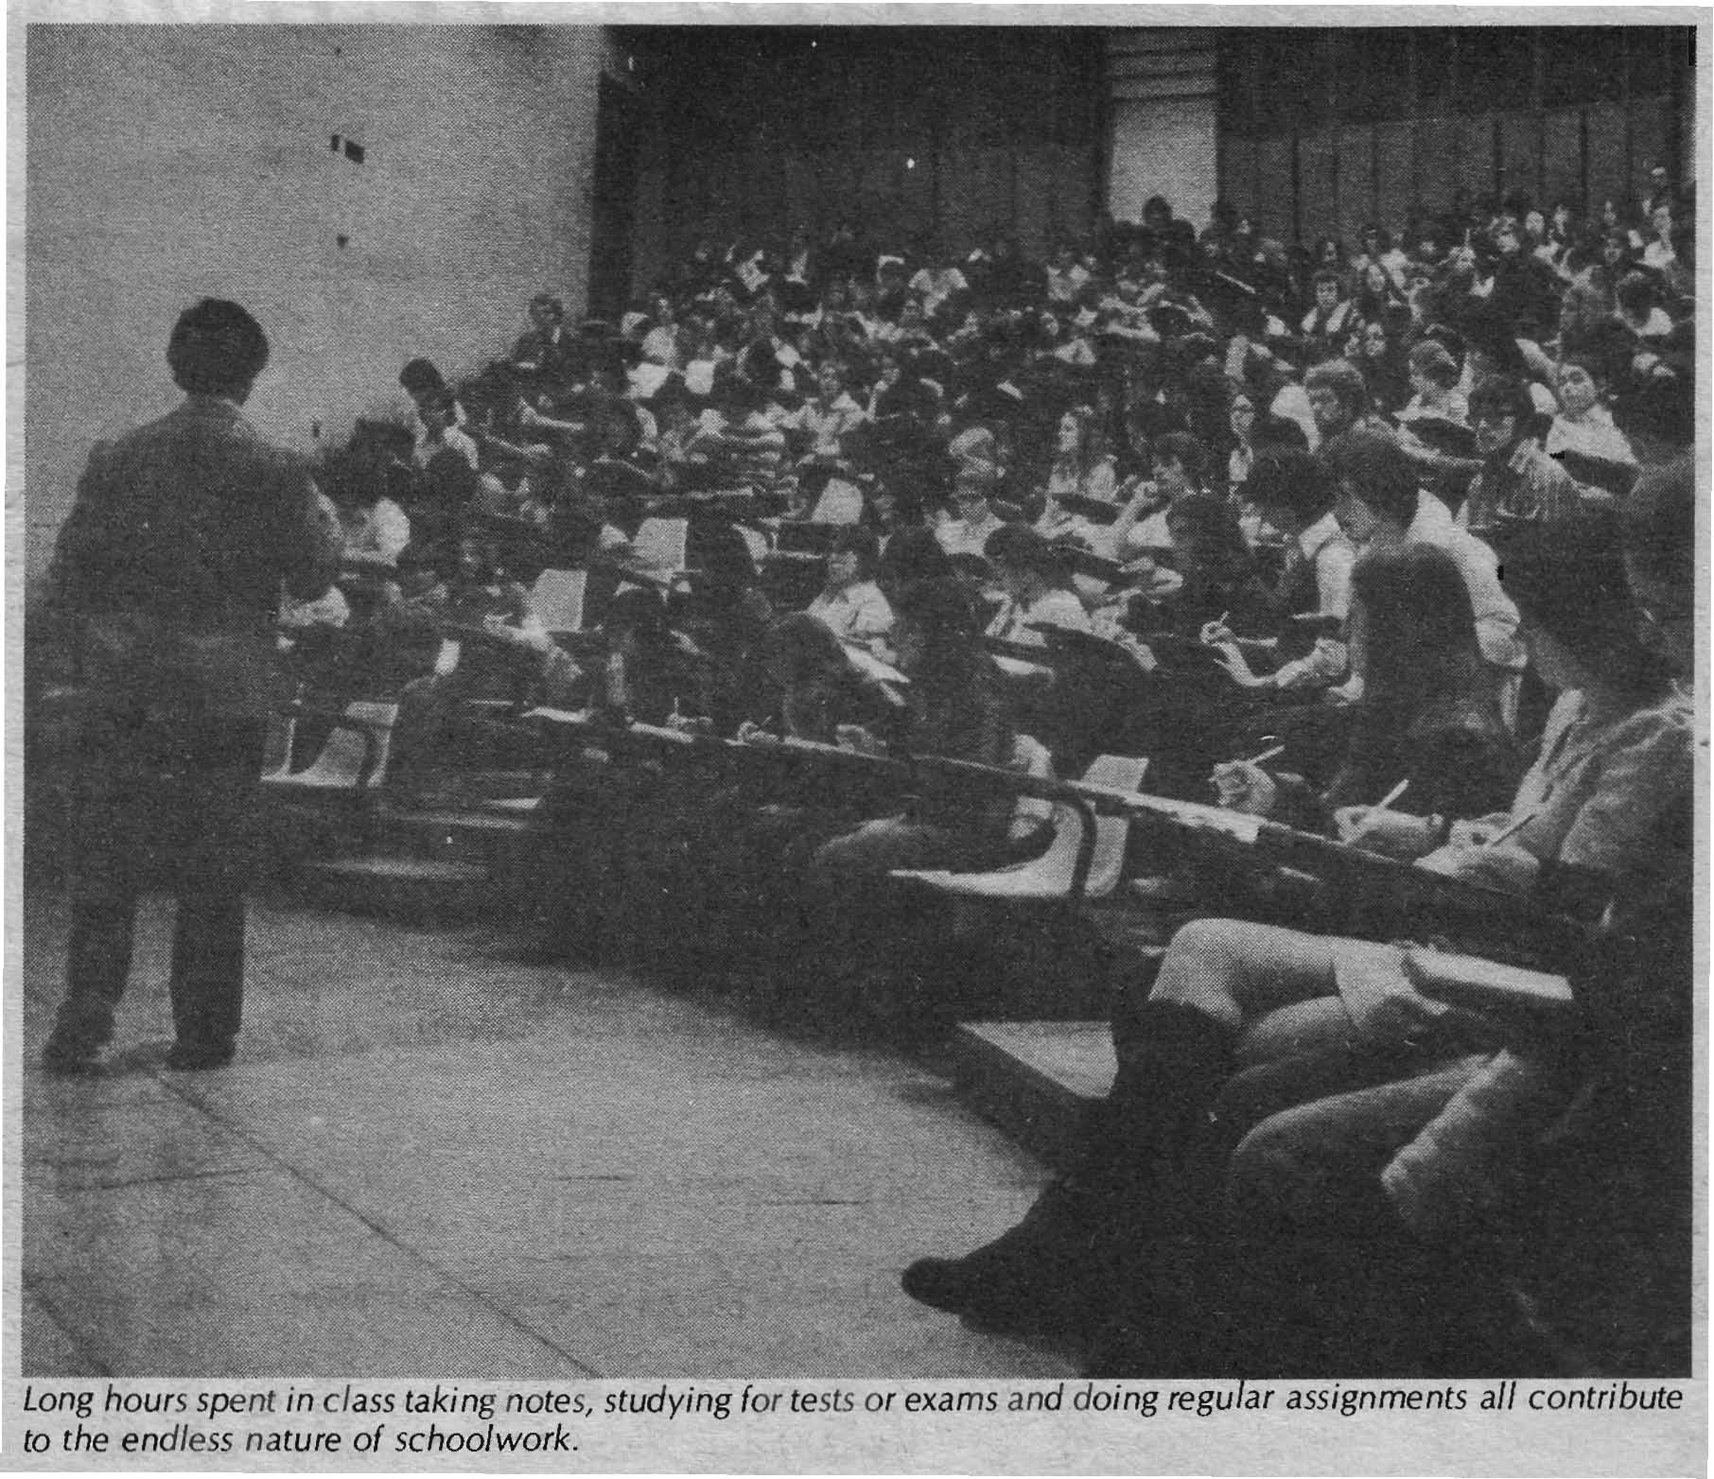
Thus the state intervenes and manipulates the structure, format, costs and working conditions of schoolwork in much the same way it does in other workplaces.

Students' struggle against schoolwork

When we recognize that going to school is work for us, it's possible to begin to understand the various ways we have been struggling both against work and to gain access to some money, or a wage, for that work.

In high school, the struggle against schoolwork takes many forms. A recent Toronto board of education report shows that 24 per cent of Toronto high school students dropped out in the 1973-74 school year. This represents a sharp increase over previous years.

Although the report designated six different categories of drop-outs, the common thread running through all of them is that school, with all its rules and regulations, was too much of a hassle, too much work, on the other hand, all categories expressed the need to have a wage of their own.

Vandalism in the schools, like sabotage in factories, also expresses students' struggle against schoolwork. In the U.S., officials estimate that schools spend as much on vandalism costs as on textbooks.

In Toronto, despite the installation of electronic surveillance devices in "vandalism-prone" schools, incidents of vandalism continue to increase. Officials reported last fall that among the thousands of dollars in cash and equipment stolen the previous year, only one book was taken. What better indication of the refusal of schoolwork?

Dropping-out⁻and vandalism are only two of the most visible forms of students' struggle against schoolwork and for access to a wage (or the goods a wage enables us to acquire). For students who remain enrolled in school, truancy or absenteeism has been on the rise, despite the liberalization of discipline in vocational schools and the new credit program in all high schools.

Students are also increasingly refusing the daily discipline of schoolwork. A Toronto teacher was asked recently by a student teacher I know who determines how much homework is assigned each day. He replied that the students themselves decide — students have simply refused to do homework, so teachers like himself have just stopped assigning it. Other teachers describe the increasing refusal to accept authority and a generalized rebelliousness among students.

When all these forms of struggle against schoolwork are seen as isolated or individual actions, it seems a bit much to describe them as a "struggle". But when the majority of students engage in some of these activities all the time, and when employers are complaining loudly about the poor quality of the product of schools, we are forced to recognize the daily actions of students as a struggle against their work of producing themselves as the future labour force.

Struggle against schoolwork at university

Our struggle against schoolwork at university also takes on a variety of forms. It involves skipping classes, using the same essay for several courses, helping fellow students with assignments.

The avoidance of schoolwork can also be a pleasant love affair, long conversations in pubs with friends, reading the wrong book at the right time and the right book at the wrong time. Those of us who have enough money frequently buy term papers from essay companies

One of the most tangible results of students' struggle over the past 10 years has been the steady erosion of the grading system. Schools, employers, and the state use the grading system to check the "quality" of the products of the school system. As long as it functions, grading forces students to work harder and compete with each other for jobs or places in graduate school.

Increasing criticism by students of authoritarian learning and the refusal to do a lot of schoolwork has significantly reduced the use of the bell curve, and grade levels have risen steadily.

Now the universities complain that most first year students lack basic reading, writing, and mathematics skills, despite adequate grades in high school. Also, grades have lost much of their usefulness to employers in assessing job applicants.

School authorities describe this phenomenon as "grade inflation". From our viewpoint, when we struggle for higher grades for less work, we are making a similar struggle as that of waged workers, whose struggle for more money and less work is called "wage inflation" by the state.

We students have not only been struggling against schoolwork; we have also been fighting for money in various forms.

In the late 60's, federal and provincial authorities were faced with a widespread refusal, of university students to pay back their student loans. By 1970, more than 50 per cent of outstanding loans were not being repaid. In this way, students were refusing the discipline and the pressures that a huge debt creates to quickly find a job after graduation.

Since then, student loan regulations have been tightened up to prevent students from simply taking money for schoolwork by refusing to repay loans.

Students also get access to goods which a wage usually permits through shoplifting books, food, clothes, etc. A few years ago, there was a citywide campaign against shoplifting in Kitchener-Waterloo, which suggests that not only students, but also workers in stores and warehouses, have supplemented their income in this way.

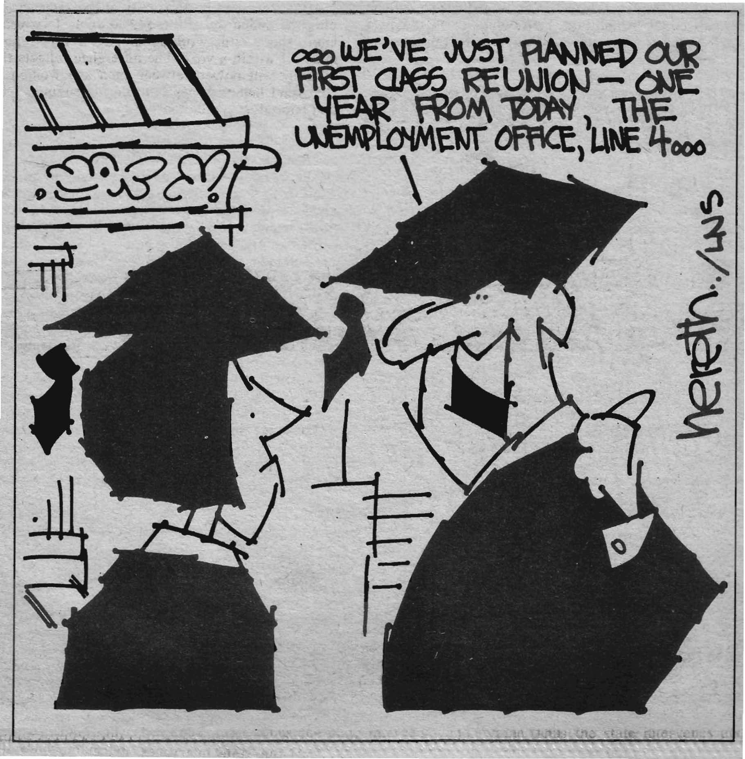
In the last few years, university students have been organizing around how much money they get from the state for schoolwork. In 1976 already there have been large demonstrations of students at Queen's Park, at the New Brunswick legislature, and at the University of Calgary over grants and loans.

In a three-week Quebec-wide strike by community college students last year, students demanded that their parents' income should have no bearing on student grants, and that all students should get a guaranteed annual wage equivalent to welfare for a single person. The fact that even getting welfare would be a big gain shows how little our work is valued at present.

In effect, the Quebec students were demanding wages for schoolwork, without being quite so coherent, It should be noted that community college students in Quebec pay no tuition, so they already had a significant amount of leverage or power to reduce the level of indebtedness that wagelessness usually means for Ontario students.

Similarly, the opposition of Ontario students to decreases in grants and proposed tuition increases shows clearly that we think we should get more money, not less, for going to school.

The Ontario Federation of Students is demanding free tuition and a "living stipend" for university students. This is a positive move, but unless we make clear that going to school is work, and we want to get paid for it, it will be difficult to avoid the traditional blackmail that we are a "privileged" group living off the backs of the taxpayers.

These recent actions by Canadian university students demonstrate that we already receive a form of wages for schoolwork through the grant system. The Ontario Student Aid Program is just that. It's interesting to see how the government calculates the cost of food, books, housing, transportation, etc. to determine what it costs for a student to stay alive. From the state's and employer's viewpoint, that's what a wage is — what is necessary for us to maintain ourselves so we can continue to work for them.

Other categories of students also receive a form of wages for schoolwork. Thousands take Canada Manpower Training Programs, and receive a subsistence wage while at school. High school students who leave home can get welfare if they stay at school. Also, the Canadian Armed Forces pay university students to go to school if they enroll in officer training programs.

The difference between all these forms of wages for schoolwork and an explicit wage for schoolwork is that they all assume that schooling is a privilege rather than work, so we should be glad to receive less than welfare and accumulate large debts. When we demand wages for schoolwork, we make clear that schoolwork is a job like any other job, and that we want a lot more money than mere subsistence.

Wages for schoolwork

Although we and other students have been struggling against schoolwork in all kinds of ways, as well as getting some money, our weakness has been the failure to fight for wages for schoolwork in a direct way. When high school students drop out, they are forced by the lack of power that comes with wagelessness to take jobs for the minimum wage (although they seldom remain tied to them).

When we finish university with large debts, our wagelessness forces us to find a job quickly. Frequently we even have to lie about our education in order to get temporary jobs in offices and factories. Our power to date has been built through our refusal of schoolwork and our limited success in getting some money. But we need wages for schoolwork to further develop our power to decide how much work we do at school and whether to take part-time or full-time jobs after graduation.

Like housewives, when we are not paid for the work we, do, the state doesn't care how many hours we work -a day. But when we demand wages for schoolwork, we make visible all the unpaid work school involves, and we can begin to struggle, like other workers, over how much of our time we are forced to submit to schoolwork for how much money.

In this way, we will be able to take time off from schoolwork without having to feel guilty. Wages for schoolwork will also remove much of the anxiety we experience about having to work hard and perform well in school in order to get a good job.

Wages for schoolwork will not only mean having the power to refuse part-time and summer jobs in addition to schoolwork, but will also enable us to reduce much of our schoolwork.

The idea that we should get wages for schoolwork is not something that fell out of the clouds. It emerges precisely at the time when the state is trying to impose more work for less money on all workers, waged and wageless — through transit fare increases and reduced services, daycare cutbacks, rising food prices and energy prices, and wage controls.

As we examine all the unrecognized and unpaid work we do at school, we shouldn't forget that other workers are struggling to get paid for all their work too. When women, for instance, struggle for more and cheaper daycare, lower food prices, or the availability of safe abortions and birth control, they are struggling over the amount of work they are forced to do.

And now women are organizing for wages for housework — not only in the home, but all the unpaid work they do outside the home too. And when men workers struggle for more money and less work, as they've been doing in record numbers and with "alarming" success in the last few years, they are fighting for wages for all the work they do both on and off the job.

Thus, while the state is trying to get more schoolwork for less money from us, we are not alone in wanting more money, more time and less work for ourselves.

To the extent that we get paid for our work at school, and are not forced to compete for jobs with other workers, we will give them more power to struggle for more money and less work. So winning more power for ourselves gives other workers more power also.

Last year, Ottawa lent $142.3 million to 140,000 students under the Canada Student Loan Plan. As the federal government raises its defense spending this year from $2.5 billion to $5 billion, and prepares to kick in another $200 million for the Olympics, let's not forget there's more where that ⁻came from!

About six months after this article was published, The Chevron was charged by the Federation of Students (a group that oversaw student activities on campus) with having come under the influence of radical students and was shut down. The result was a nine-month free-speech battle that spread from campus across the university, the city, the province and the country. The editors of the paper eventually won that battle and the paper was reinstated in June 1977. Source: The University of Waterloo, Daily Bulletin, June 21, 2002.

