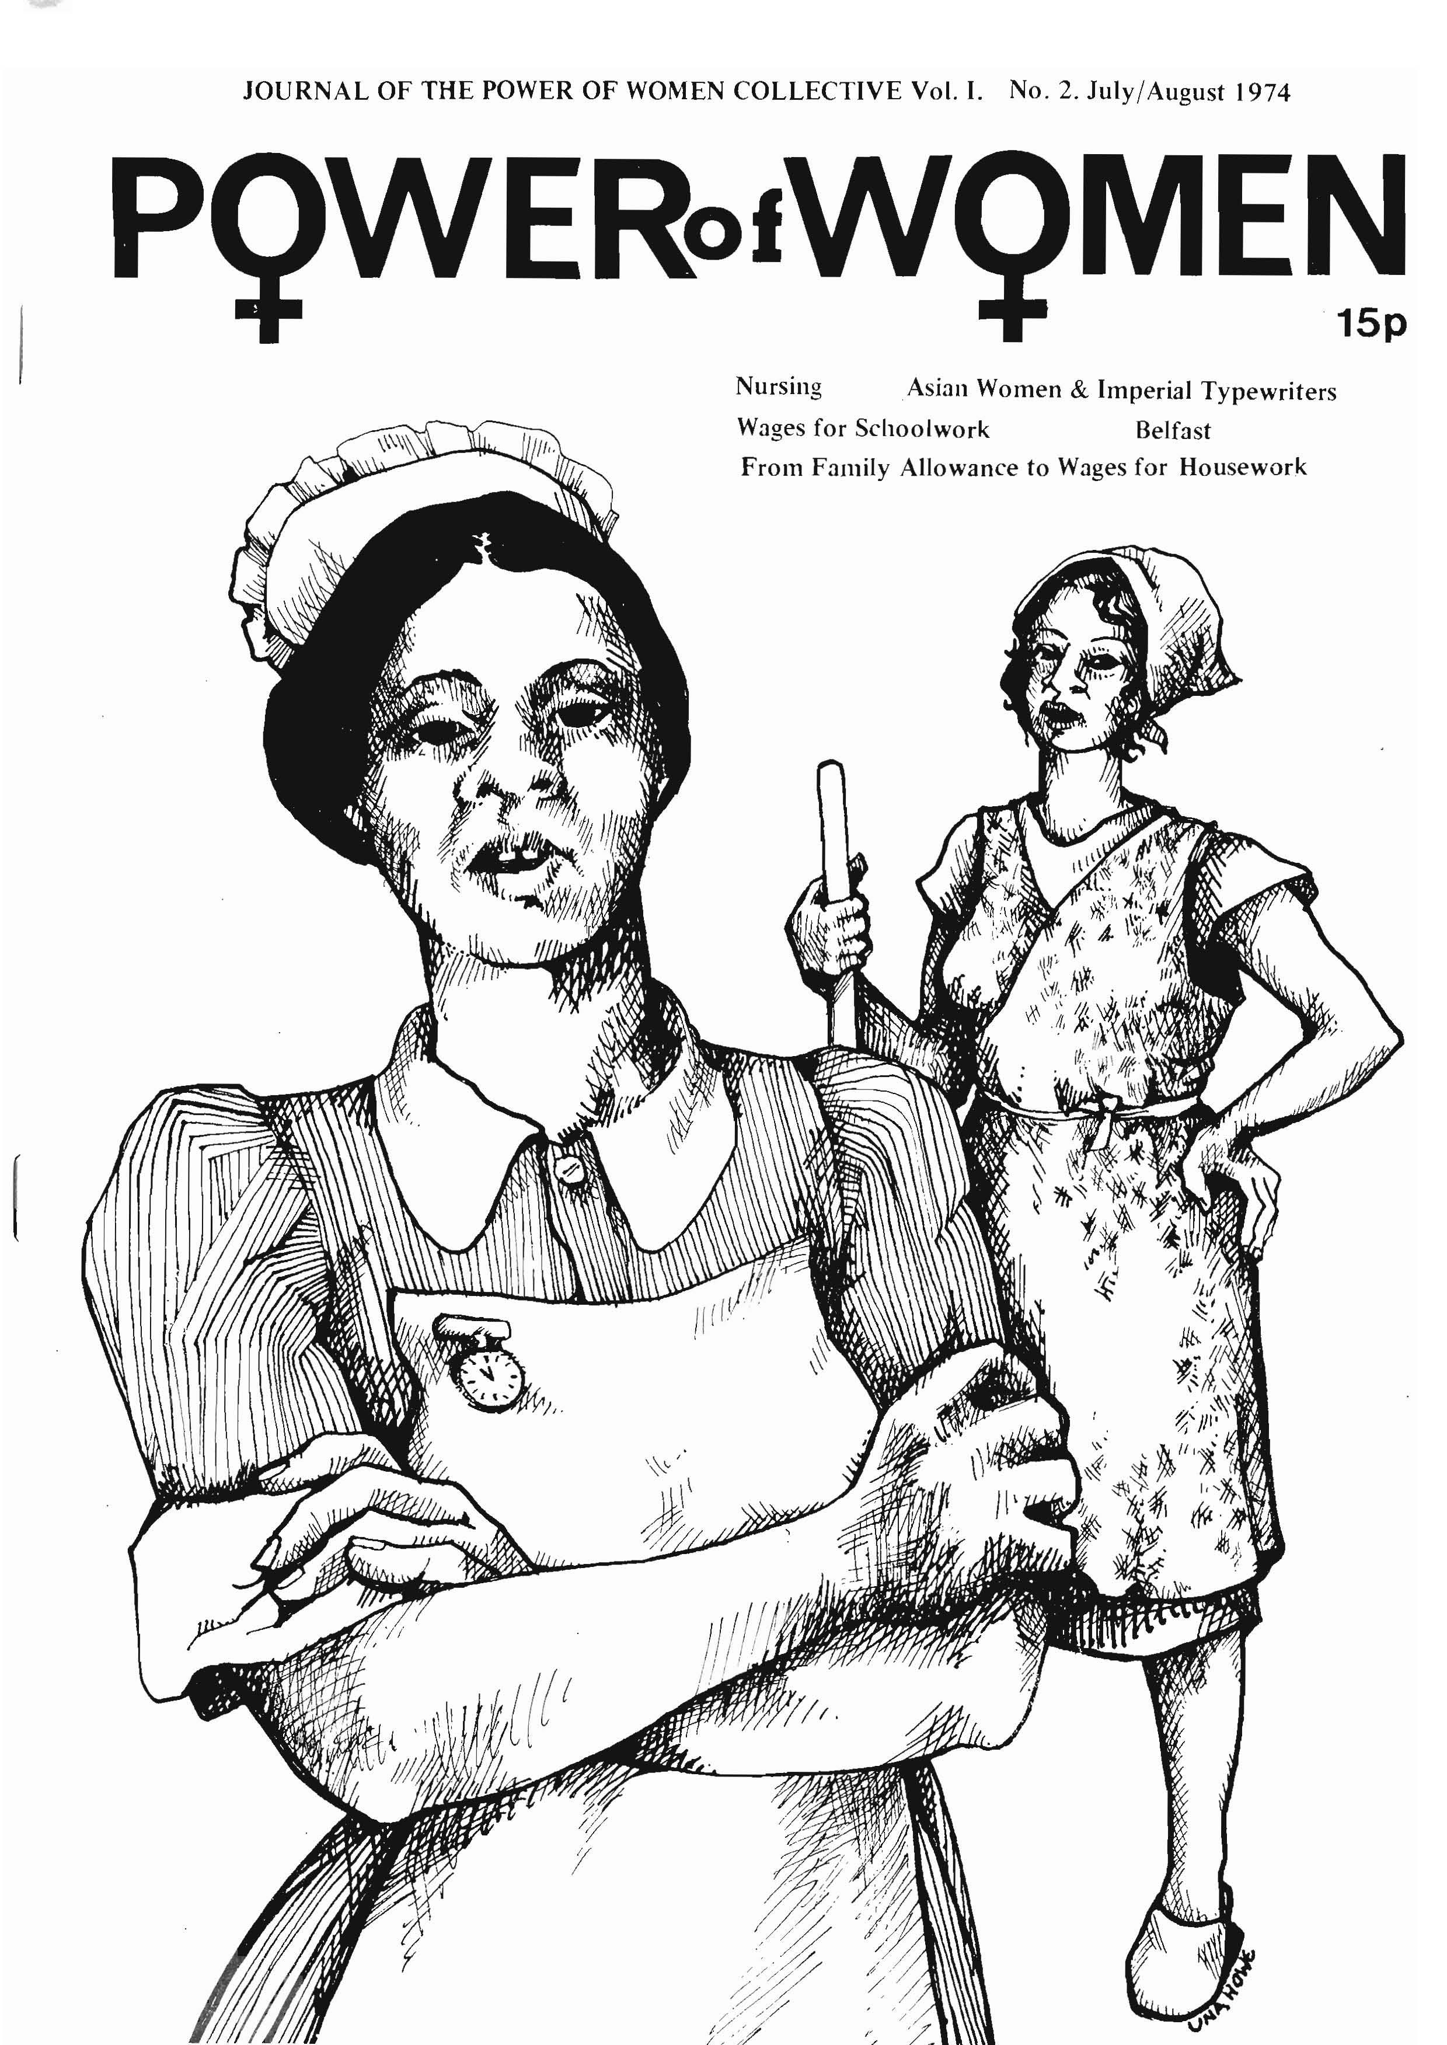
JOURNAL OF THE POWER OF WOMEN COLLECTIVE Vol. I. No. 2. July/August 1974
Nursing Asian Women & Imperial Typewriters
Wages for Schoolwork Belfast
From Family Allowance to Wages for Housework

WAGES FOR SCHOOL WORK

Below is a conversation with Gaye and Karen, two students from a mixed comprehensive in South London.
POW: We understand that you've been circulating a petition on wages for schoolwork. What gave you the idea?
GAYE: Well at school. Our teacher wrote an article for a magazine telling people that there should be wages for schoolchildren and he gave us one to read, and we thought it was a good idea.
POW: Did you then just discuss it among yourselves? KAREN: No. First of all we was talking about it to the whole class. And then me and Gaye, we set up petitions, and we
asked people if they agreed that we should get a wage to sign a piece of paper, and it has on it: 'This is a petition for a wage for schoolchildren', and anyone who agreed would sign. And we went all round our school. For one lesson we spoke to a class, and we had a discussion with that class about school wages and did they agree. And they were asking us where would the money come from, questions like this.
POW: Did the teachers just let you walk in like that?
KAREN: We had to be careful. Like some teachers don't agree and they would have chucked us out of the class. So we asked each teacher first did they agree. And if they said yes, we said, well can we see your class? And they said yes. But if they didn't agree, we just passed them by. Most of the teachers said yes. It was only a few that said no.
POW: The first time you all went to a first year class to speak were you scared?
BOTH: Yeah.
KAREN: We were careful not to put them off it but not to give them false facts. We had to tell them what we thought. Like we said, school-leaving age has gone up. If it never, you could be out earning a wage. Or if you didn't go to work, you couldn't get a job, you'd still be getting money off the State, wouldn't you, like the dole. So you're staying at school and you're not getting paid. And if you was a fifth year, what was your idea, would you like to get paid for coming to school? And they said, yeah.
POW: What did they say was wrong with the idea?
GAYE: Where is the money coming from was the main one. KAREN: And would the government tax their parents more. And we weren't really sure but we said we thought like Ford, the one who makes a lot of profit, like the rich people, they would get taxed more.
POW: Was the teacher there during this discussion?
KAREN: Yes. He was asking us questions, asking them questions, asking them to ask us questions, like involving us all. And like one child said, why not pay our parents that wage? But then the government would tax them, whereas the government can't tax us.
GAYE: And like, if we was naughty, they'd say, oh you're not getting your money today, and all things like these. Like if we had our own wage, we'd be independent.
POW: So how did you feel after this first session?
GAYE: Great.
KAREN: Yeah, you know, we thought, we put our feelings over and now we're getting moving. It's not just like our own opinions. Lots of people do agree and lots of people are prepared to come on strike or a demonstration, you know. POW: Did you discuss that in the classroom, about strike or demonstration?
GAYE: We didn't say it was a strike. We said, it isn't just for skipping school or just for laughs; it's for those people who believe in what we're doing.
KAREN: It's not for kids who want to have a half-day off or something, just to go home and have a muck-about or just a 'lark. It's got to be dead serious. It they believe in it, then the
best thing is to stay at school.
6
POW: So then you went to other classes. What did they ask you? GAYE: The pupils in the first year, they said, how much do
we get paid?
KAREN: 'We want £10 a day' or something like that. But we said we don't know.
GAYE: Fifty pence a day to start off, and we thought, when the fifth and sixth years get it, then the fourth years will go on strike and they'll want it. And gradually it'll go all through the school. And they'll all want it in the end. And then they'll go on strike for more money when things go up.
POW: What did you tell people about signing the petition? KAREN: Like we discussed the school wage matter, and we said, if you agree with it, sign the paper. But we said we won't show this paper to anyone so it won't like get you into trouble. And we said, we're going to go on a demonstration soon; would you be prepared to come? And most of them said, they would. And we said, you don't have to come; we're not pushing you to come, but it would be a good thing if you'd come and support us. And they said they would.
GAYE: The people that didn't want to come and support us, we got their names on another piece of paper.
POW: They were for the wage but they weren't for the demonstration?
KAREN: Yes.
GAYE: If we could get just a few people from all the schools in the south London area, and then one night we have a meeting and discuss when we're going out and then we'd print some pamphlets saying what day, and then we just distribute them all over the schools. And then on that piece of paper has the date that we're going on strike.
POW: What do your parents think about this?
KAREN: Well my dad said he agreed in some ways but he's not so sure because he thinks it'll come iike he'll get taxed more and that. And my mum, she agrees except that she doesn't know where the money's coming from either.
GAYE: Well my mum agrees with it. She signed her name and she said that if we had the march she would even come along with us. And my dad agrees. My mum said she would take off work that day and so would my dad.
POW: Do you think that your parents, Karen, who are not so much in favour of it, would try to prevent you from going on your demonstration?
KAREN: No. My dad said if ever I agreed with anything I should do it. If I knew all the facts, the proper facts, you know, and if I really agreed with it, I should do it. Like there was a strike for the Brockwell Three and I went on that. And I told my mum and my dad and they said, well if I really did agree, then I should go on strike.
POW: One of the problems that we've had in explaining wages for housework is that sometimes people ask us the same questions they ask you about school wages. And sometimes we can't give them an answer. But it still doesn't change our minds.
What do you do when you can't answer?
KAREN: Well we've just set ourselves up. It's not an organisation or nothing like that, you know. And so I say, well we'll open the discussion soon, we'll raise that question, I say, because I've got no answer for that question just yet.
GAYE: On Friday we was gonna go out and interview people in the park, men and women, to ask them what they thought of it. But we broke up early and so we didn't get the chance. But with a bit of luck we'll do it this Friday.
KAREN: We can go round the streets with a tape recorder and just stop a passerby and say, we believe in a school wage, and we'll say why we believe this, and that. And if they agree, you know, ask them their views on it.
(Continued on p.13)

(Continued from p.6)
13
GAYE: And if they don't, we'll still ask them their views on it and why they don't.
KAREN: We'll play it back in school and maybe it'll give us some rough ideas what to do.
POW: I noticed that you say 'wages for schoolchildren' sometimes. Are you a child?
KAREN: No. For school pupils.
GAYE: Because we put it this way. If you're on a bus if you're over 14 you have to pay full fare. If you're over 14 and go to the pictures you have to pay full to get in. Well how come if we can't go out earning a wage or if we're going to school and don't get no money for doing work in school, why should we have to pay full fare in the pictures to get in and on the buses and trains?
KAREN: I typed out a thing and on it I put 'students' or 'pupils'. I never put 'children'.
GAYE: You know, like our fifth year, they don't stay at school. Although the school-leaving age has gone up, they try and get a job somewhere where the people will take them because they want to get paid, they want to be independent. KAREN: There's a girl in our fifth year, there was a cafe over the road, and she used to work in there.
POW: After school.
KAREN: No, in school hours. And teachers used to go over there and they used to see her and they didn't say nothing to her.
POW: But a lot of people don't go to school at all.
KAREN: They prefer to get some kind of a job to be paid. But if they knew they was going to get paid at school, then they'd come.
POW: But aren't there a lot of young people who don't go to school and don't go to a job that's paying tither?
GAYE: I don't know. Like my mate, she goes over the Oval House and that's like a place where young people go and they have drama over there, of a night time and of a daytime sometimes. And there's a free school and once it's legalised sort of thing, she wants to go there. She prefers to go there, because you can go in when you want and you can have what lesson you want when you want it.
POW: What do you think is the difference in the need for a wage between women and men of your age ²
GAYE: I've not actually thought of that question. The boys, they get paid more anyway. From their parents. If they get a job, right, they'd get paid more anyway. And also their parents always give them more because they are boys like. It's the natural thing, boys can stay out later than girls.
POW: It's not a natural thing.
GAYE: Well it may not be natural but that's what happens. My brother is younger than me. And his last birthday he was 12 and I'm near 15. I had a big argument with my mum because in the weekdays I've got to be in at 10 o'clock. And they said that my brother's got to be in at 10 o'clock too. And I made a big argument about it. It's not fair at all.
POW: What about the amount of money that a woman spends? I notice, Gaye, you have eye makeup, and I know it's expensive. GAYE: It's not fair though, really, because men get paid more. Yet they don't have to pay out for the little things like we
have to.
KAREN: They don't wear tights either.
POW: Are you going to raise this in your campaign?
KAREN: Well I don't know, really. This really isn't a fight against men; it's just for the wage for all of us. The main point is they're fifth years and they've had to stay on.
GAYE: But there again the boys work the same hours as us and do the same amount of work, and if they say boys should get 10 bob extra, and the teachers agree, we'll fight against it.
POW How much housework do you do?
GAYE: I have to make me bed every morning and change the sheets on a Sunday and dust me own bedroom. And then we
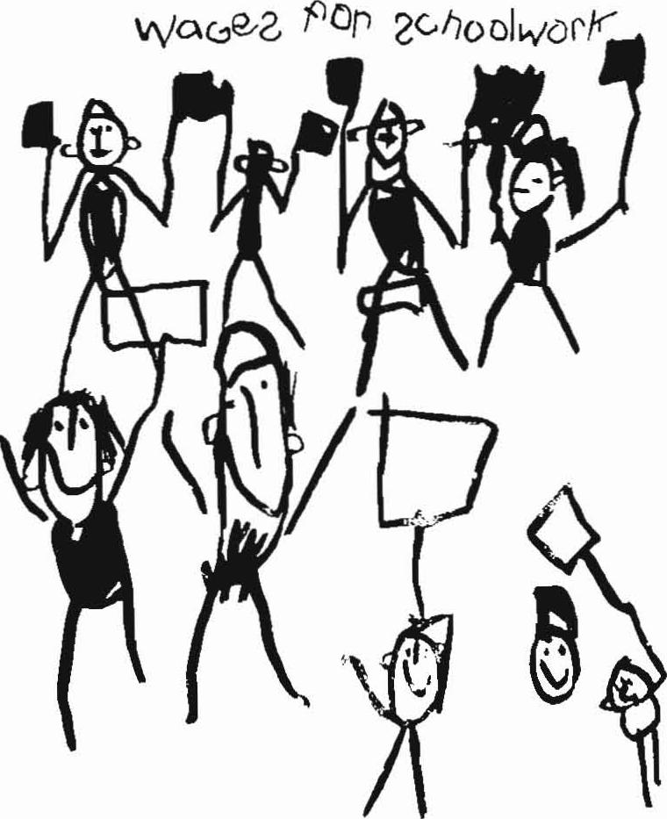
Drawing by Alexis Wood
take turns: it's either me mum does the washing up teatime or me do the washing up and she does the wiping.
POW: And what does your brother do?
GAYE: Go in the living room and watch telly
POW: So it's all thrown on your mother.
KAREN: Yes, but there again, certain people say, what's a mum for? She's supposed to do the beds and the washing.
POW: Are you going to do it when you get married?
GAYE: If I have children, one does the washing up, one does the drying, one does the cleaning. But the point is that if my mum went in hospital my brother would know what's hit him, know *hat I mean?
POW: You're now fourth years. But you're fighting for a wage for when you're fifth years. Why not for all school students? KAREN: Because in about the fourth or fifth year, you need more than what you really did in the third year and the second, because you really like more clothes if your mates have got clothes
POW: What ao you have for spending money now?
GAYE: I got two jobs. I'm partly employed in a doctor's surgery some evenings for about a fiver a week. And then I work Friday night for the tenants' association selling tickets for blind children.
The government in the last ballot, they said that in September they're going to try and stop all jobs for children under 16. Like if you work in Woolworths, you've got to have a work permit. And that'll be more sort of towards a school wage, because they'll think, oh no, they've not got a job now, and they ain't got so much money, so what are we gonna do? POW: Your mum has a job outside the home and she has a bit of cash of her own. If she was a full-time housewife you would be in trouble, wouldn't you?
KAREN: Yeah. But I don't get a lot of money, you know. I only get however much I need to go out, like a couple of bob a night. But my mum can't always do this. Sometimes she say 'You know, money don't grow on trees', and 'I only got a part-time job, you can't expect me to give you this, go and scrounge off your dad,' something like that.
GAYE: Yes, but if your dad only went to work it would have been worse still, because you only get that much money because they're both at work.
KAREN: Yes. And they give me the money because I need it. I'm not old enough so I can't get a wage from a job. So really, you know, it would be good if I had a school wage. It would make me more independent instead of having to say, oh mum, can I have some money, or dad, can I have some money?

